Kinetic Molecular Theory

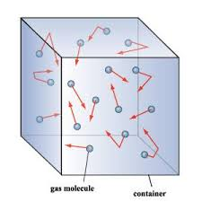
Kinetic Molecular Theory explains how atoms and molecules behave in different substances and environmental conditions.

Blow up two balloons. Take two containers big enough to hold the balloons and fill one with hot water, and one with cold water. Make a prediction – what will happen to the balloons when they are submerged in the water? Submerge one balloon into the cold water and the other balloon into the hot water. Wait several minutes and then compare the sizes of the balloons. Return each balloon to its original bucket, wait several more minutes and compare their sizes again. Draw what has taken place and compare the results with your original predictions.
  - How did temperature impact the molecules?
  - Why did changes in temperature affect the size of the balloons?

