Homeostasis
Intrapersonal
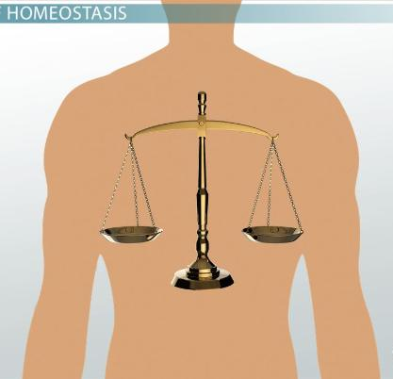
Our body maintains a consistent balance in multiple systems. Body temperature, blood sugar, oxygen saturation are just a few examples of the balances our bodies maintain.
Go to the Body Control Center. Try the activity there.
Modern medicine often seeks to try and restore balances that have been disturbed. For instance when blood sugar become irregular (diabetes), we use insulin to try to regulate sugar levels. Research at least two other medical interventions related to homeostasis – how do they work?

