Mathematical Patterns

Choose a story that has a pattern. Represent the pattern in at least three different ways (e.g. using pattern blocks, an equation, a diagram, musical instruments, etc.)

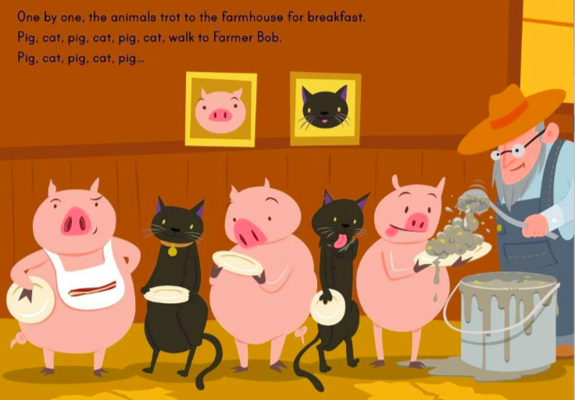

Historical Timelines

Research the history of one local Indigenous group. What were the most significant events in their history?
Create a pictorial timeline to tell the history of the nation you selected.
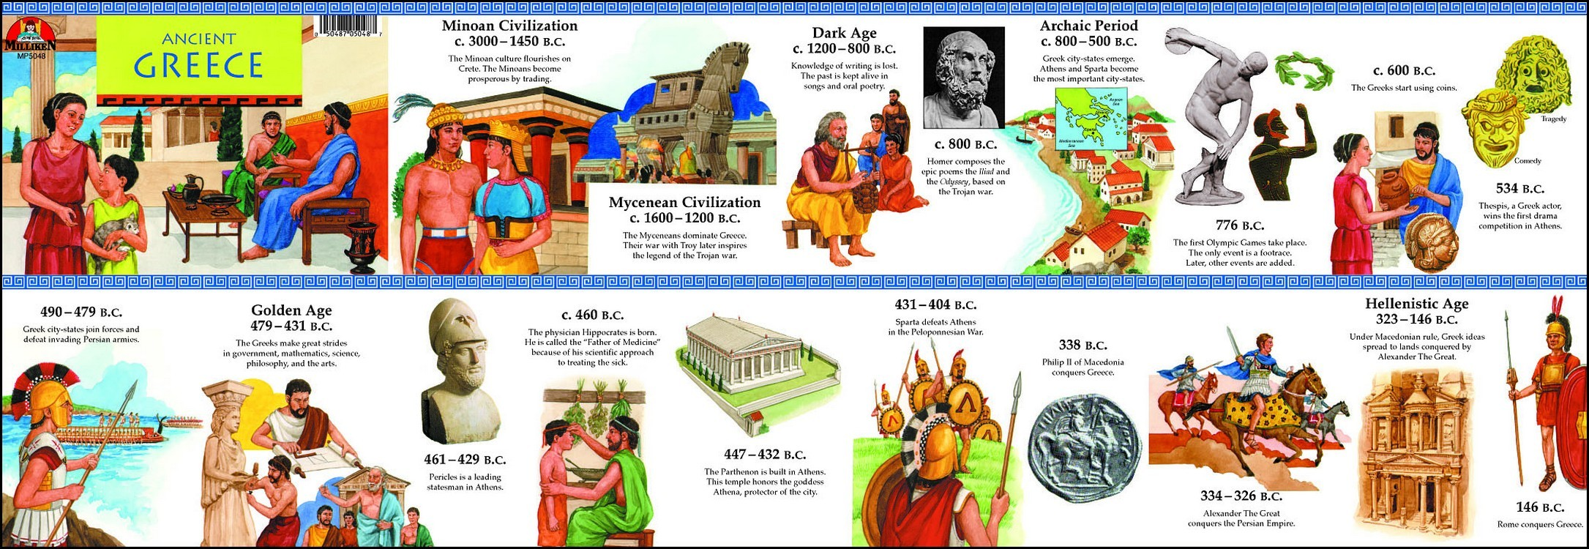

Energy Rap

Write a rap about the flow of thermal energy.
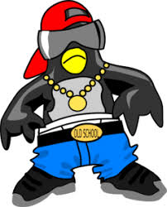
Use correct language about conduction, convection, and radiation.

Songs of the Oppressed
Write a protest song an Indigenous Canadian past or present might rightfully sing.
You may use instruments or computer programs to assist you.
Use appropriate melody, beat, and lyrics for the mood you wish to create, and the message you are trying to send.

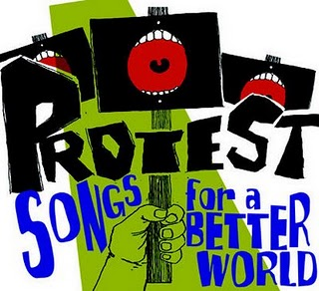

The Story of My Life
An autobiography is the story of someone’s life, written by them. You can write a story of one important event in your life, a year in your life, or of your entire life!

Prepare your story to be told to the class.
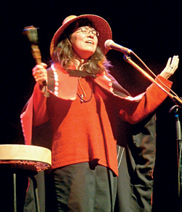

Creation Stories

In your center there are several different creation stories.
Choose two to read.

What do you notice are the common characteristics of a creation story?
Write your own creation story, and prepare to tell it to the class.
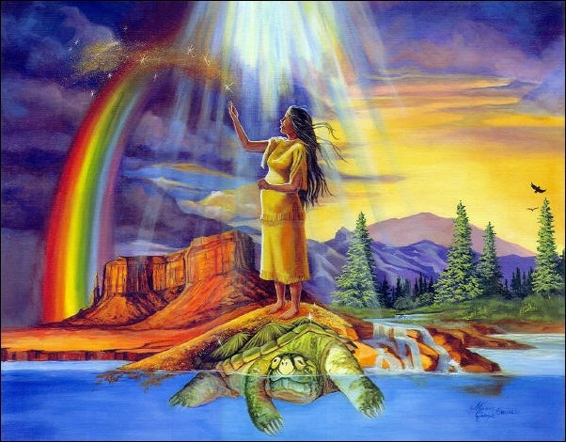

Energetic Diagrams

There are many ways we use thermal energy in our lives. For instance, boiling water involves radiation (from a fire), conduction (through a metal grill or pot), and convection (through the water).
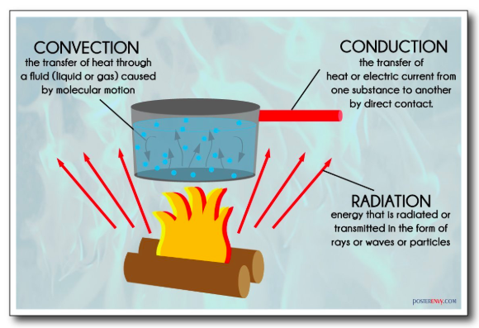

Create a diagram (or three diagrams) that shows another example of thermal energy transfer through conduction, convection, and radiation. Be sure to illustrate the direction of energy transfer

Indigenous Art

Indigenous people often used art to tell a story.
For instance the two row wampum belt records the meaning of an agreement, which declared peaceful coexistence between the Haudenosaunee and Dutch settlers in the area.
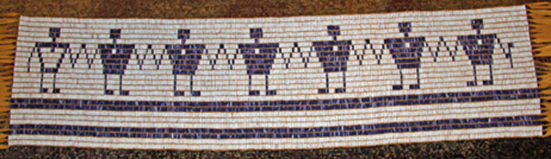

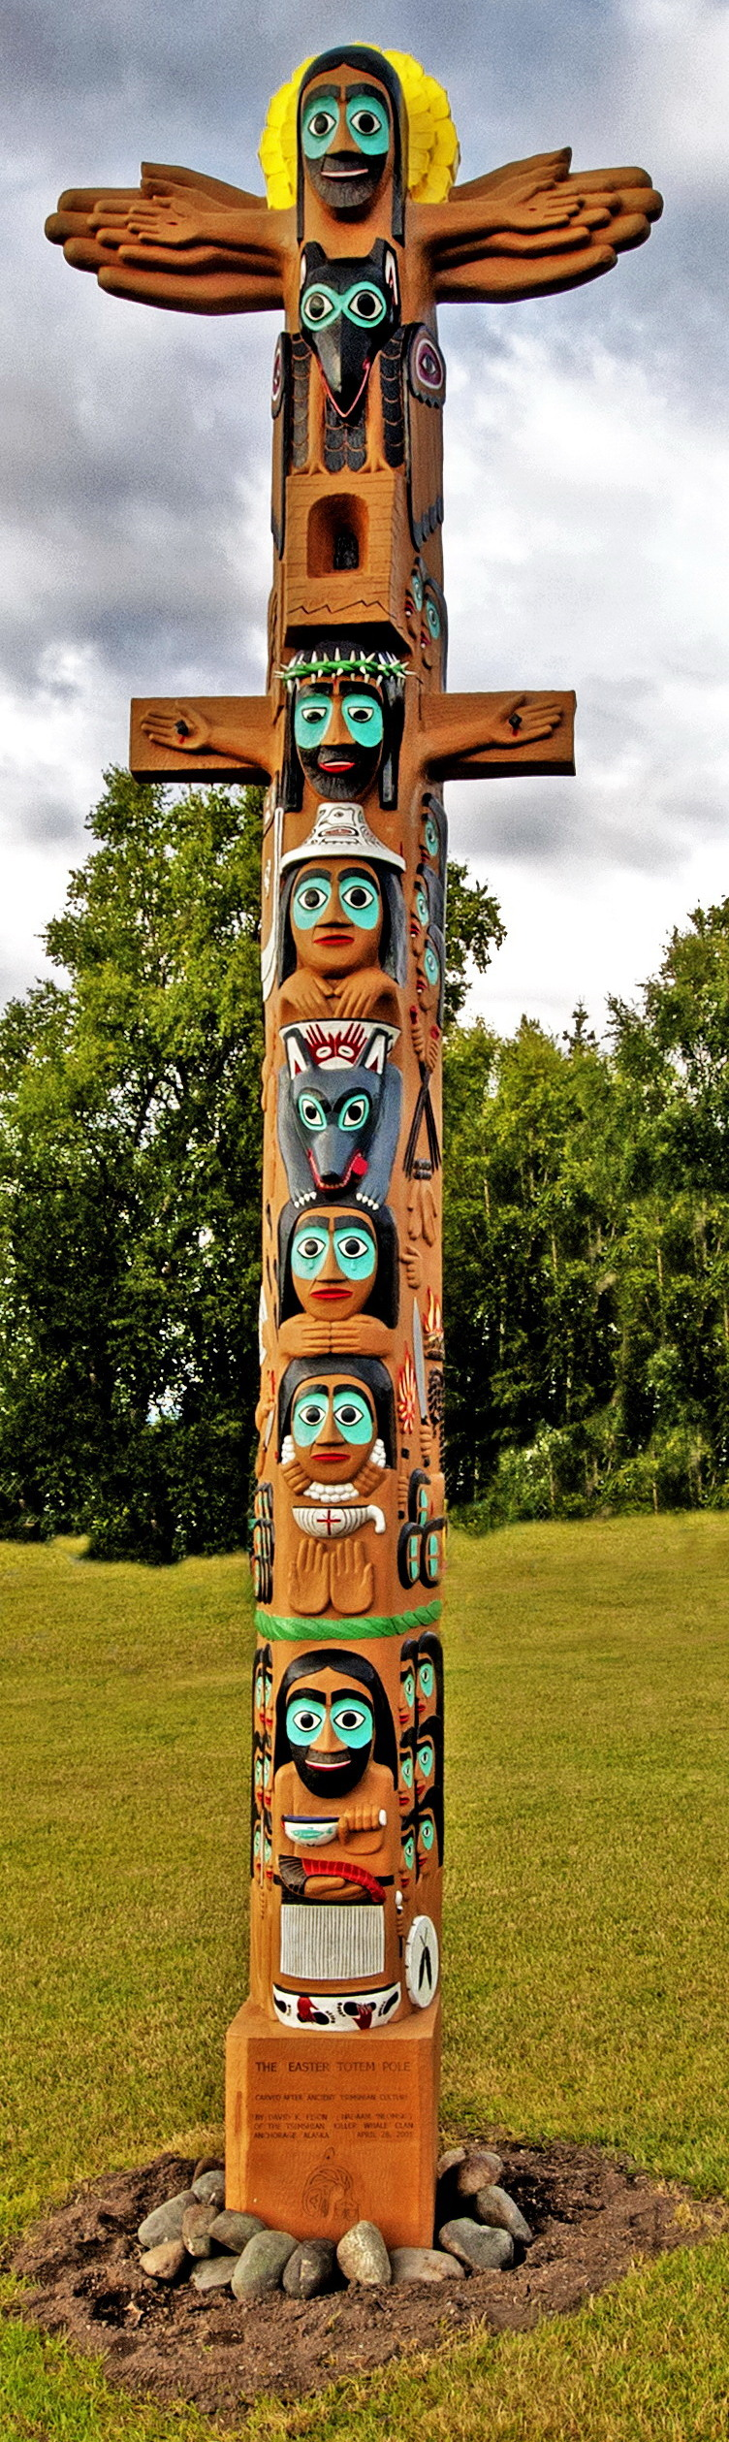
Similarly totem poles are a traditional way of telling the stories of Aboriginal families and clans, and of keeping records of important historical events.

Create a piece of art to tell a story from your life.

Physical Re-Production

Create a dance or mime to tell a story from a local Indigenous culture.

Set Design

Select a story from the center.
Design and construct a set and props for performing the story.

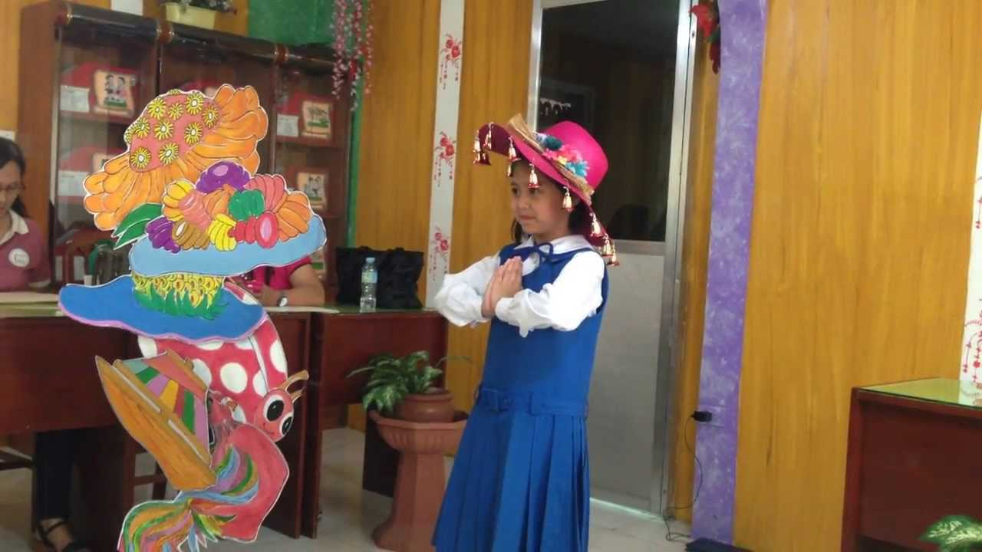

My Stories

Research stories from your own culture. What do you learn from your stories about yourself, your family, and your culture?

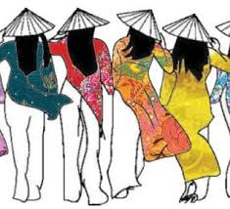

Staying Warm, Keeping Cool

In Canada, weather changes can be dramatic. What ways do you use to keep warm? How about to cool off?
List some of the ways you keep warm and cool, and discuss whether they are examples of conduction, convection, or radiation.

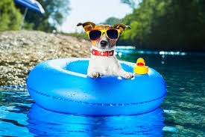

Humanity at Our Core

Read the poem “No Difference” by Shel Silverstein.
Think about what people of different cultures all share that makes them worthy of respect and care.

You can write, draw, sing…
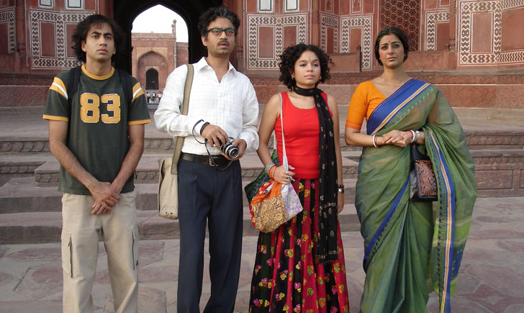
Stories and Spirit
Many cultures use stories to communicate spiritual beliefs, celebrate spiritual milestones, and create ceremonies.
Stories can “raise our spirits”, and they can teach us values and morals.
Select a story from your center. Think about what it teaches us.
What was the creator trying to say?

Create a story to share something you care about.
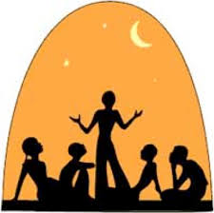
Predicting Evolution

Think about sources of thermal energy in nature, and how we use them. As global warming progresses, we are likely to need less sources of heat, and more sources of cooling. How will we manage that change?
Write and illustrate your vision, with justifications/explanations.
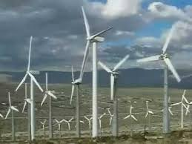

Indigenous Fire
Indigenous peoples in Canada used fire-keepers to control the forests, built homes that centred around fire, and used smoke in many spiritual ceremonies.

Compare modern uses of thermal energy and Indigenous practices in terms of their impact on the environment.

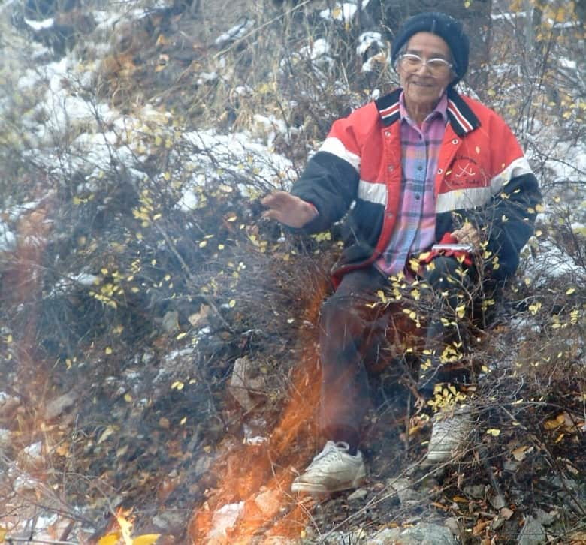

Human Conductors

Human beings are conductors. We can share body heat to warm someone up, and we can pass electricity to another person. What else do humans conduct? Think about how we pass/share other forms of energy, ideas, emotions, and more.

You can write, draw, sing…
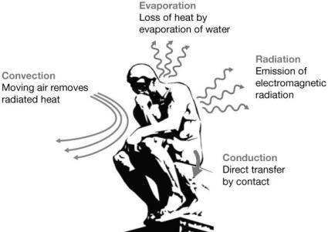

Cultural Patterns

Cultures around the world use visual patterns, musical patterns, and more to symbolize their culture.

Create a pattern to share your culture with others.

