Mathematical Power

Exponents use the language of “power.” Governments also have “powers” – the ability to make laws, and enforce them. Using equations and exponents, depict levels of Canadian government and their power in relation to Indigenous peoples. Keep in mind that in some aspects, provincial governments held power, while in others federal or municipal governments did.

How could an equation depict this?

X² + -3Y⁴ x 2 =

Resource Economics
In Canada, provinces are often referred to as “have” and “have not” provinces. In fact, wealthier provinces transfer payments to poorer provinces to help maintain “equality.”
How does geographical and human diversity influence the economics of “have” and “have not” provinces?

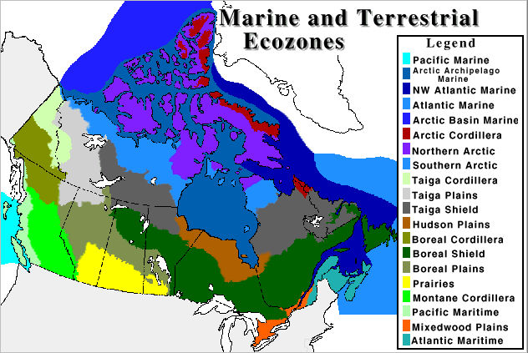

Musical Re - Production

Write a rap explaining the process/stages of human reproduction.
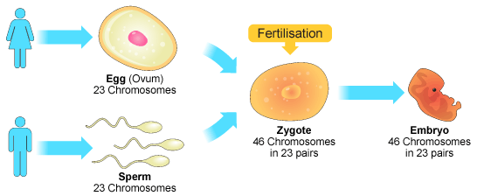
Use correct language for the stages from conception to birth.

Songs of the Oppressed
Write a protest song one Canadian past or present might rightfully sing.
You may use instruments or computer programs to assist you.
Use appropriate melody, beat, and lyrics for the mood you wish to create, and the message you are trying to send.

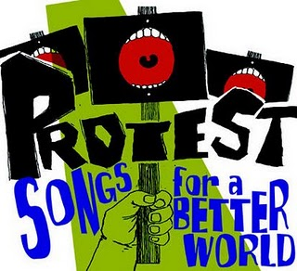

Legal Protection
Write a bill for parliament that protects human rights related to biotechnologies. In the bill, state your arguments for why members of parliament should pass this bill.

Communicating in Numbers & Words

Write a story that explains the equation,
Z = - X + 3y in relation to a heredity pattern or social issue.
(For example, for every lost woman’s vote, three more ___ lead to ___)

Visual Re-Productions

Draw genetic trees illustrating mitosis and meiosis and the genetic makeup of the offspring that result.

Canada in Art

Create a piece of art depicting diversity in Canada.
You may use any materials you wish – be creative!
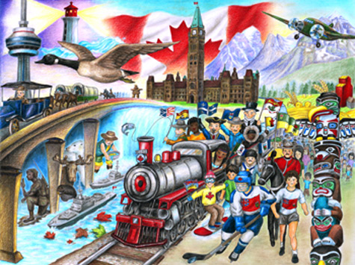
Physical Re-Production

Create a dance or mime to demonstrate natural selection, mutation, and artificial selection.

Kinesthetic Expression

Design and construct a model of a new biotechnology for artificial selection.
Be Creative!
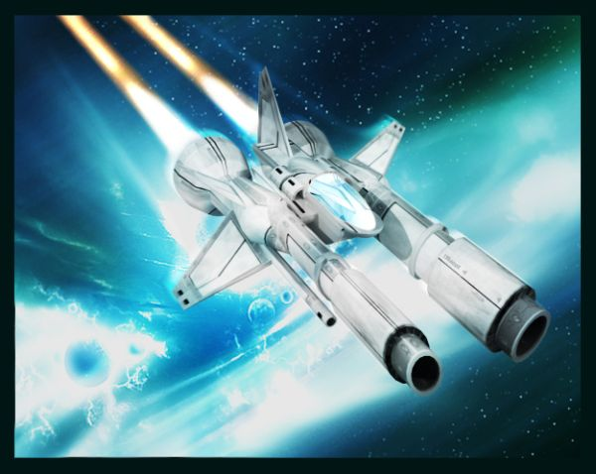

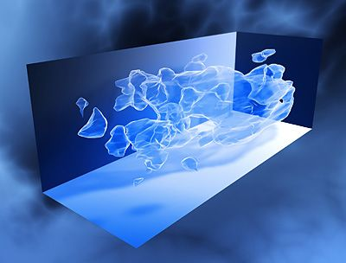

Family Genetic Tree

Create a genetic tree for three traits (e.g. hair color)
within a family (your own or another).
How have these traits been passed down? What diversity has resulted?
Is there any evidence of mutation of adaptation?
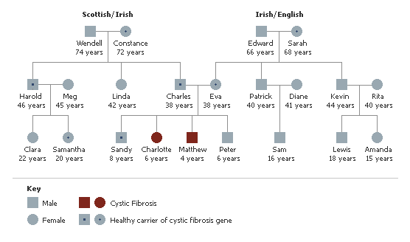

Geography & Me

How does where you live (geographically) impact your life and the diversity around you?
You may draw, write, or sing…
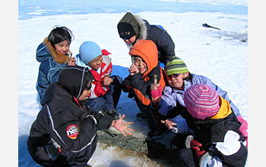

Environmental Influence

Are adaptation and assimilation comparable?
Why or why not?

You can write, draw, sing…
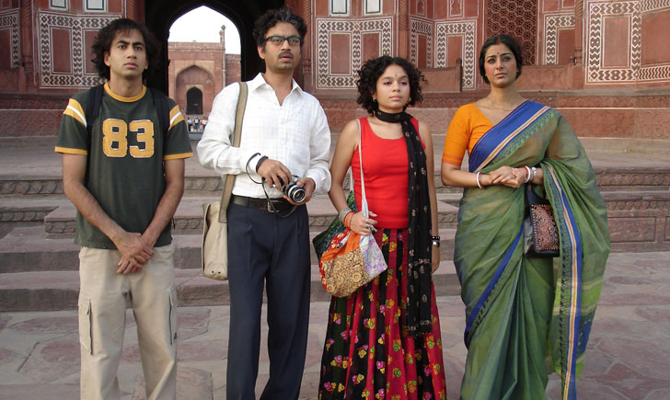
Predicting Evolution

Choose a species that lives in Canada. Predict mutations or adaptations that species might make in the decades to come given current environmental changes.
Write and illustrate your vision, with justifications/explanations.
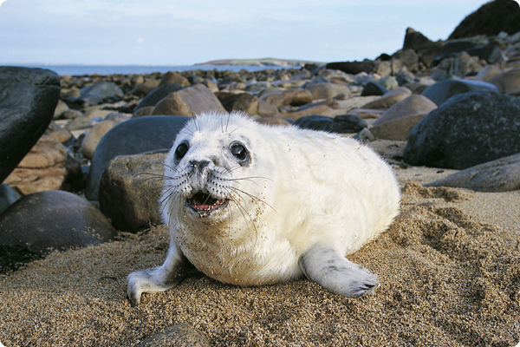

Poetic Expression

Write two poems, in any style you choose, representing your thoughts, feelings, and beliefs about “Exploitation” and “Harmony”.

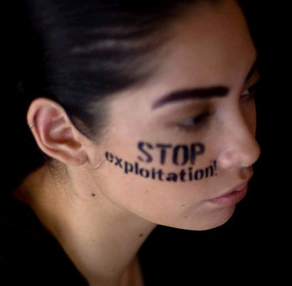

Indigenous Perspectives

Compare the perspectives of Aboriginal and European cultures regarding resource and food usage and stewardship. How are they similar/different? What do you think we have to learn from each other?

You can write, draw, sing…
