Audience Worldviews

The creators of texts attempt to impact their audience. Some creators want their audience to believe what they are reading or seeing or hearing, while others want to impact their audience’s emotions. Often, they want the audience to understand their perspective, or bias, and take actions that fit with that perspective. For instance, one author writing about hunting might argue that it is cruel, while another might argue that people need to feed themselves, and it is natural. The first author might want people to be upset about killing animals and to support a ban on hunting, the second might want people to try hunting or vote against banning it.

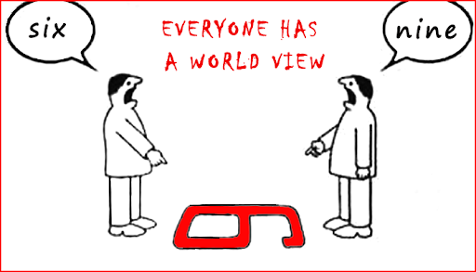
Audiences, though, enter into experiencing texts with their own ideas, beliefs, and knowledges. If someone who has never been homeless read an article about homelessness, they might understand it differently that someone who is, or has been, homeless.

Choose a topic and find two texts that are related to that topic but have different opinions (could be songs, videos, books, newspaper articles, etc.). How and why might people from different countries, genders, religions, economic means, or values and beliefs interpret these texts differently? Represent your thinking through writing, song, graphic arts, or any modality you wish.

