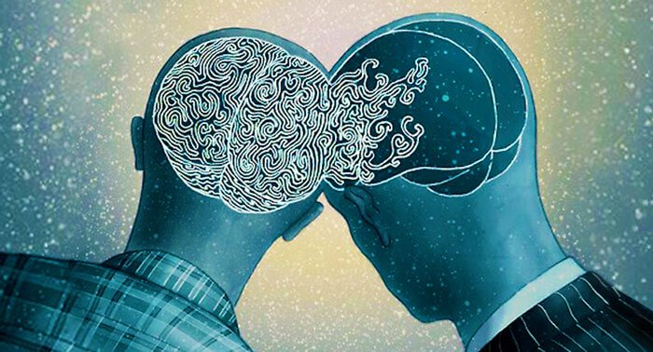

Influence & Identity

What we read, watch, listen to, and view influences our knowledge, beliefs, emotions, and values. We learn new information, experience other cultures and places, and gain perspectives from people different from us. For instance, reading about what it’s like to be homeless might cause us to have empathy for people who are homeless.

Identify three texts (books, songs, videos, websites, plays, etc.) that have influenced you (thoughts, beliefs, values, feelings) and the kind of person you are. Explain the changes you experienced, and why you feel the text had impact on you.

