Indigenous Astrology
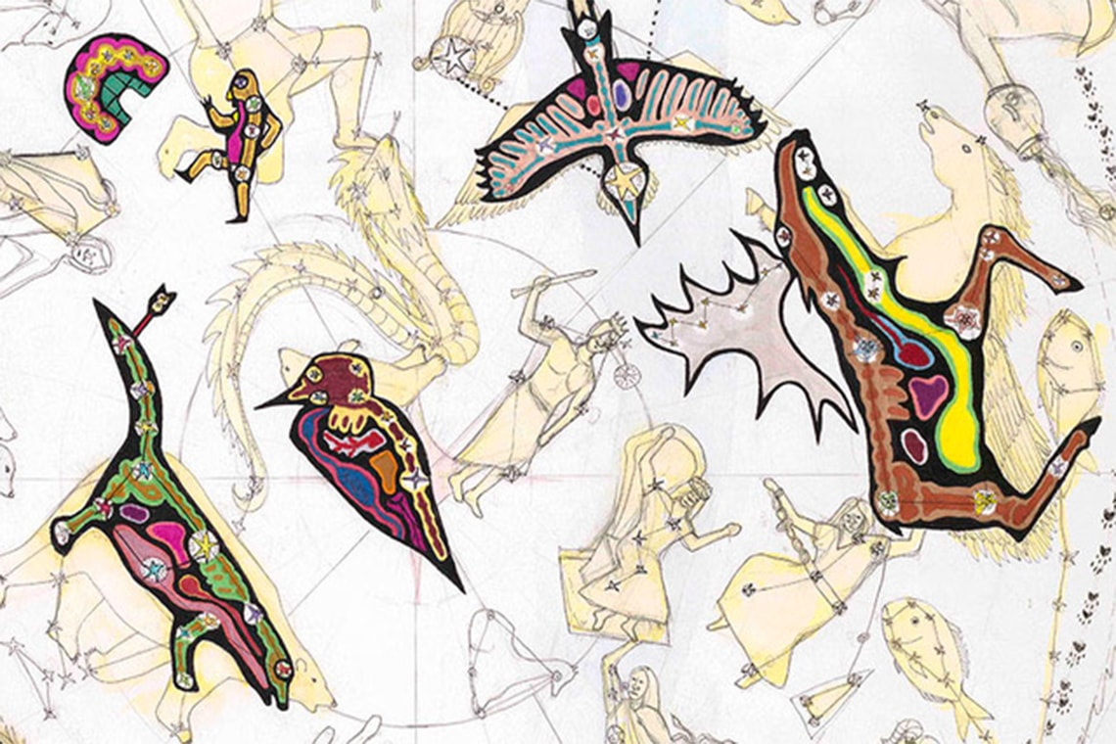
Some Indigenous nations believed the stars were spirits communicating with people. Write or tell a story about one time a spirit spoke to a person on earth about the earth and the sky.

A. Lee, W. Wilson, C. Gawboy

