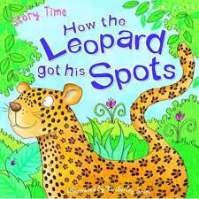
Indigenous Legends
Many Indigenous stories explained why animals looked like, or acted like, they did. For instance, a legend might tell why skunks have stripes, why rabbits have big ears, or why bears hibernate in winter.
Choose an animal you like – write, draw, sing or tell a story about why they look like they do, or why they act the way they do.

