Create a visual food web of an interdependent ecosystem.

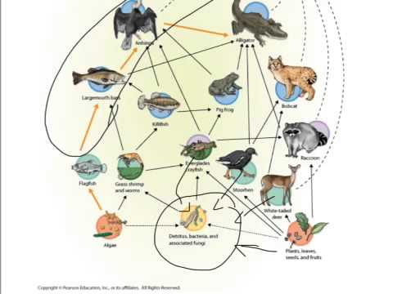
Visual-Spatial

Develop an artistic representation of an ecosystem.
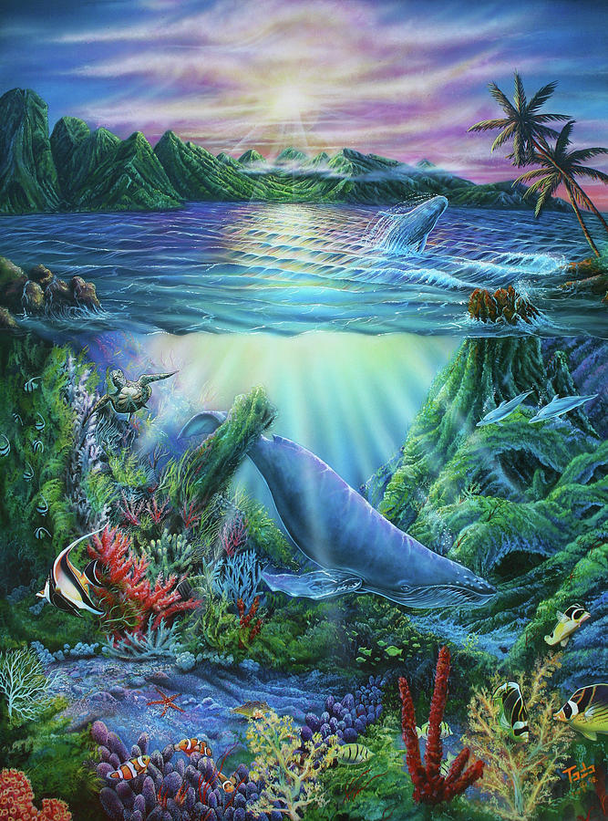
Visual-Spatial

Using some magazines or clip art, or your own images, create a mural or collage of an ecosystem.
Visual-Spatial
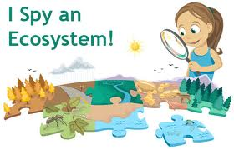

Symphonic Sound
Musical-Rhythmic
Create a symphony representing sounds of a chosen ecosystem.

Demonstrate an ideal environment for a specific organism, taking into account limiting factors such as food,
Naturalist
water, light and living space
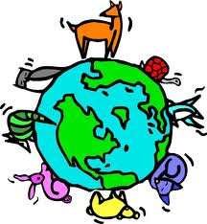

Take the perspective of one component in an ecosystem and defend the benefits of your role.
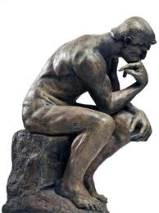
Existential

