Chapter 7—Addressing Mental-Health Needs with All Students 115

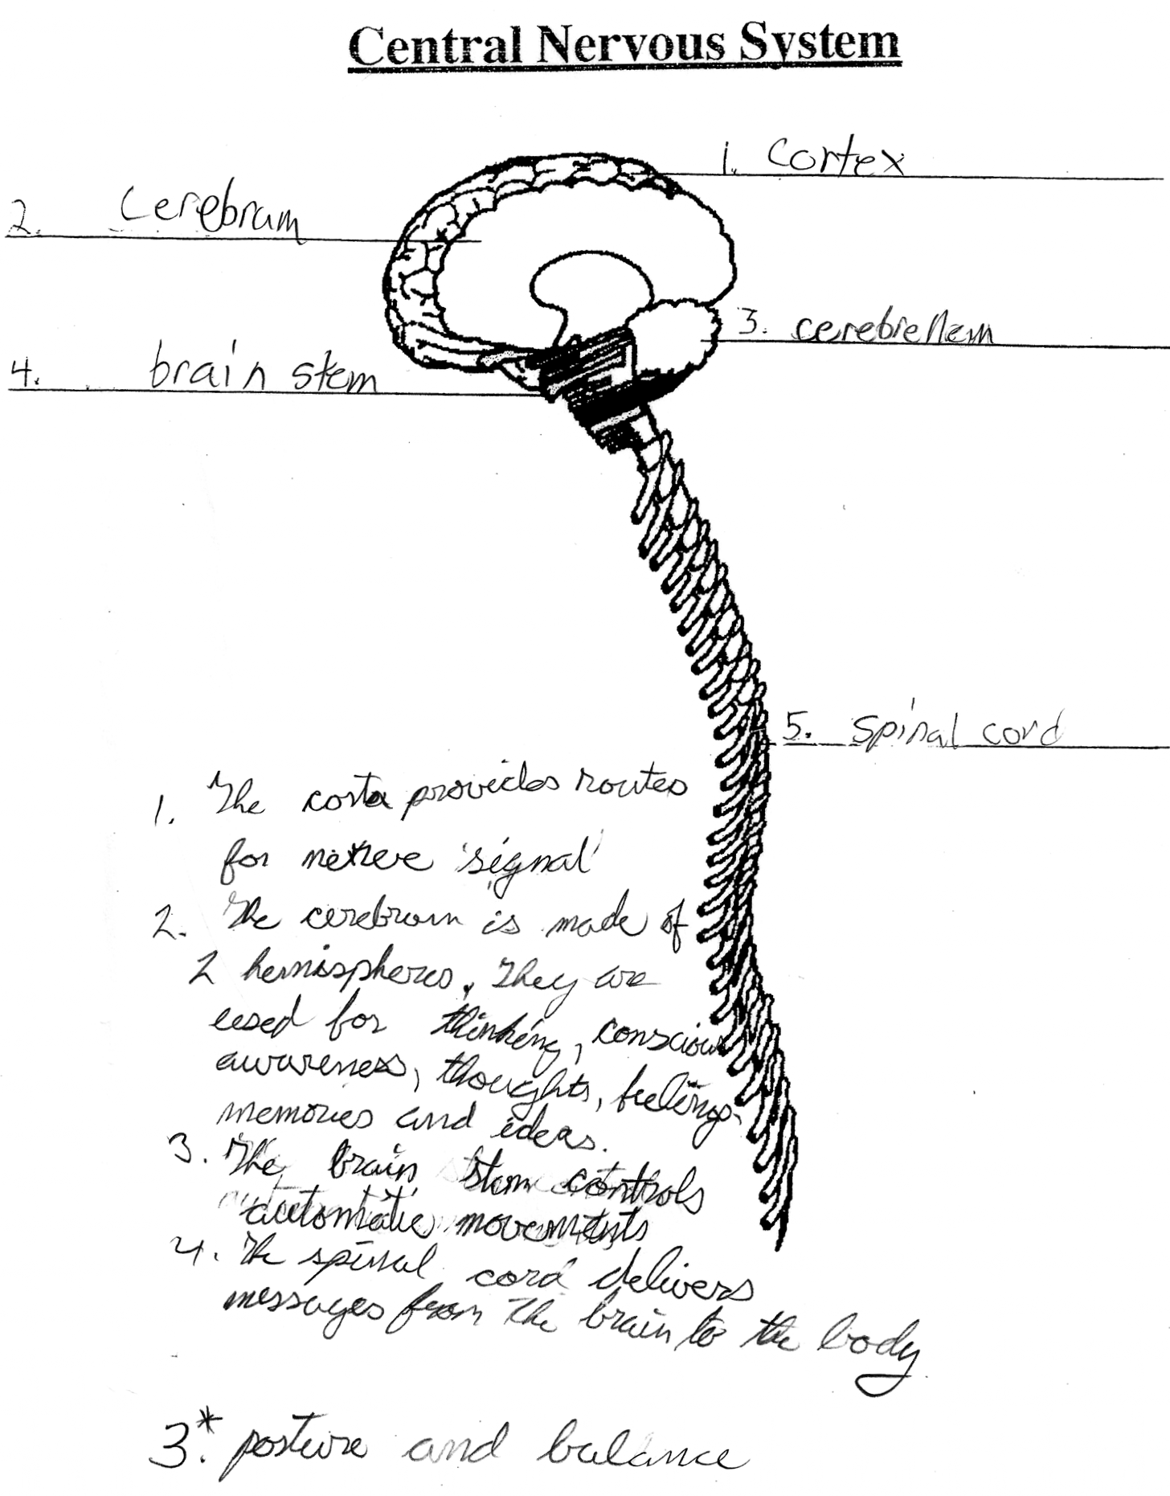

Figure 7.5 Student sample from the Brain Unit.

