Why is it important to know the past and understand history?
Verbal-Linguistic

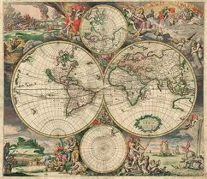

Create landforms of an ancient civilization and of Canada. Compare and contrast your models.
Bodily-Kinesthetic
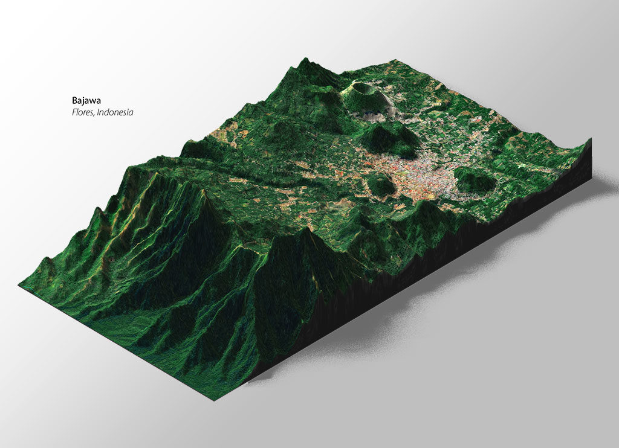

Imagine you could travel back in time to an ancient society. What is one piece of information you would share that would positively impact them?
Interpersonal

Imagine you live in an ancient society. Choose a person from that era and describe the challenges in your life through a journal entry.
Intrapersonal

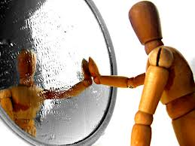

Explain why it is important to know and understand your family’s past. You can write, draw or sing.
Intrapersonal
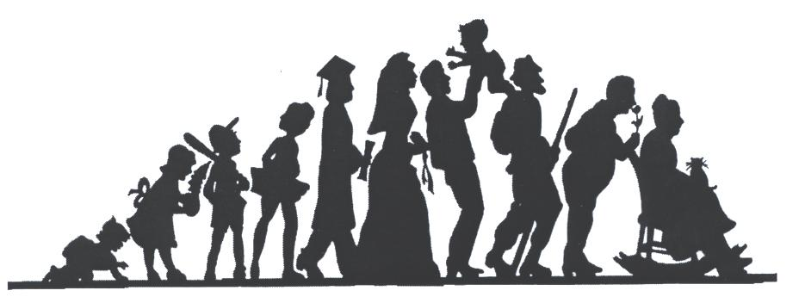

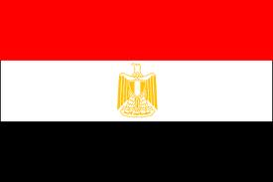
Through a role-play scenario, compare and contrast the life of a farmer in Canada to a nomadic farmer in Egypt.
Bodily-Kinesthetic

Create a poem that explains how an ancient society was affected by its environmental factors.
Verbal-Linguistic
