Change & Fighting Change

Human beings, and human societies, both seek change and resist it. Many times in history, changes have been achieved only to be counteracted by those seeking a return to “tradition.”
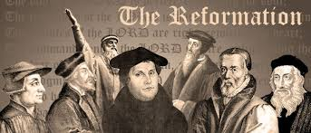
The Reformation and Counter-Reformation
are examples of this struggle.
Why do you think changing ideas created tension between the people wanting to adopt new ideas and those wanting to preserve established traditions?
How has the divisions that were created during this time impacted life today?

You can write a song, create a piece of art, make a video, or use any other media you wish to respond.

