Shape Poems
Poems use descriptive words to create images in their readers minds. For instance think of the words “happy” and “excited” – what changes in how you picture the person’s face?
Another way to create images in people’s minds is to actually write words in the shape of what is being described. Look at the poem below, how does the shape poem change your thinking when you read the poem?
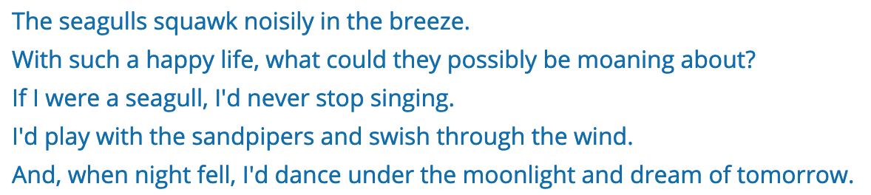
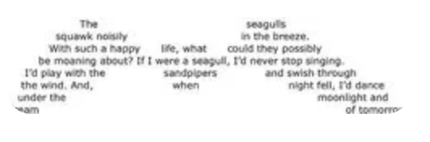

Try creating a shape poem of your own!

