Saving the Trees
Cutting down trees is bad for the environment. It means less oxygen in the air, less homes for animals, and less food. People use the wood in trees for paper, houses, clothes…lots of things!

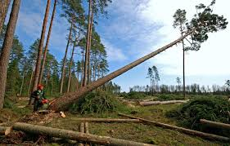
Make a list of all the things in your house that come from trees. How could you use less so fewer trees need to be cut down? Write a letter to your friends telling them how they could help save the trees.

