Chapter 7—Addressing Mental-Health Needs with All Students **115**

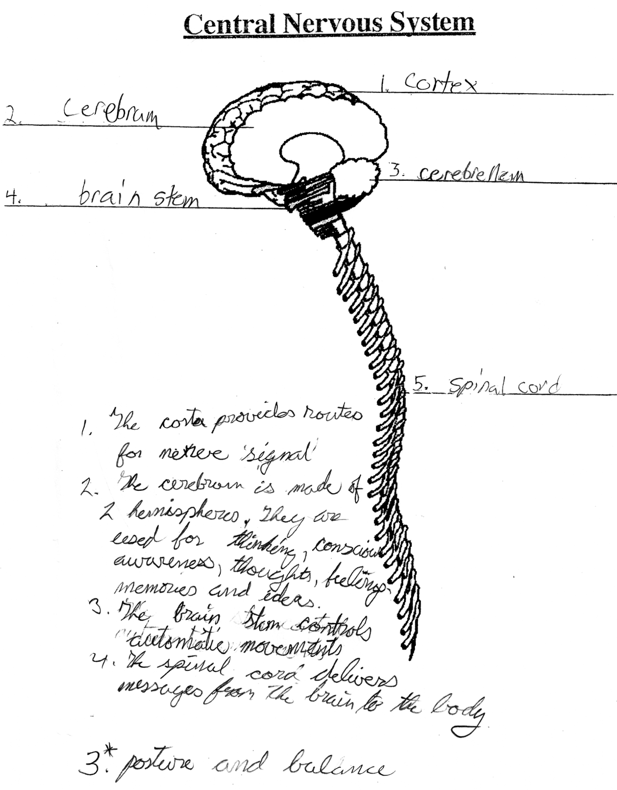

Spinal Cord

Cerebrum

Brain Stem

Cortex

Cerebellum

**Figure 7.5** Student sample from the Brain Unit.